The historical data itself contained time-series data coming from the sensors on the

planes for every flight. There are 111 different features or columns for MSN02 (Flight Test A/C) and only 17 variables for other MSNs:

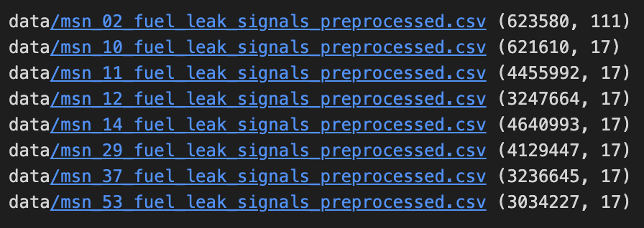

The data consisted of the following (including the column KEY in the dataset)

A/C and flight data:

* Time, day, month, year → ONLY MSN 02
* UTC date/time → UTC_TIME
* MSN (A/C Name) → ​​MSN
* Flight number → Flight
* Flight phase* → FLIGHT_PHASE_COUNT
* Altitude → FW_GEO_ALTITUDE
* Pitch and roll → ONLY MSN 02

Fuel/Engine system data:

* Engine status (Running or not). → ONLY MSN 02
* Fuel flow (to each engine) → ONLY MSN 022
* Fuel used (by engines; Kg):
  + FUEL_USED_1 → (Engine 1)
  + FUEL_USED_2 → (Engine 2)
  + FUEL_USED_3 → (Engine 3)
  + FUEL_USED_4 → (Engine 4)
* Fuel on board (“FOB” ; Kg) → VALUE_FOB
* Fuel quantity per collector cell and surge tank volume (Kg):
  + VALUE_FUEL_QTY_CT → Central Tank
  + VALUE_FUEL_QTY_FT1 → Feed Tank 1 (Engine 1)
  + VALUE_FUEL_QTY_FT2 → Feed Tank 2 (Engine 2)
  + VALUE_FUEL_QTY_FT3 → Feed Tank 3 (Engine 3)
  + VALUE_FUEL_QTY_FT4 → Feed Tank 4 (Engine 4)
  + VALUE_FUEL_QTY_LXT → Transfer Tank Left
  + VALUE_FUEL_QTY_RXT → Transfer Tank Right
* Pump status (On/Off, normally/abnormally, immersed/not immersed). → ONLY MSN 02
* Leak detection and leak flow. → ONLY MSN 02
* Fuel transfer mode. → ONLY MSN 02
* *(Flight Phases):

1. Pre-flight
2. Engine Run
3. Take-Off 1
4. Take-Off 2
5. Take-Off 3
6. Climbing 1
7. Climbing 2
8. Cruise
9. Descent
10. Approach
11. Landing
12. Post-flight